

**FORTUNE INSTITUE OF INTERNATIONAL BUSINESS**

**INDIVIDUAL ASSIGNMENT**

**MACHINE LEARNING**

**How Machine Learning Can Help a Fintech Startup**

**How Machine Learning Can Help a Fintech Startup Grow: A Practical Approach**

**Introduction**

Fintech startups operate in a highly dynamic and competitive environment where financial performance is the backbone of success. To thrive, they need to acquire customers efficiently, optimize operations, and make strategic financial decisions. With digital transactions increasing and financial services evolving, Machine Learning (ML) has become a game-changer, offering powerful solutions for data-driven decision-making.

This assignment explores how ML can revolutionize fintech startups, with finance at the core. From risk assessment, fraud detection, and financial forecasting to marketing strategies that attract the right customers, streamlined operations, and effective HR management—ML helps fintech companies operate smarter and scale faster. By leveraging data-driven insights, fintech startups can not only strengthen their financial health but also create a seamless and efficient ecosystem for sustainable growth.

**How Machine Learning is Transforming Fintech Startups**

Fintech startups operate in a fast-paced environment where financial stability, customer acquisition, and operational efficiency are crucial for growth. Machine Learning (ML) plays a significant role in strengthening financial performance while enhancing marketing, operations, and HR functions. By leveraging ML, fintech startups can automate processes, improve decision-making, and create better customer experiences.

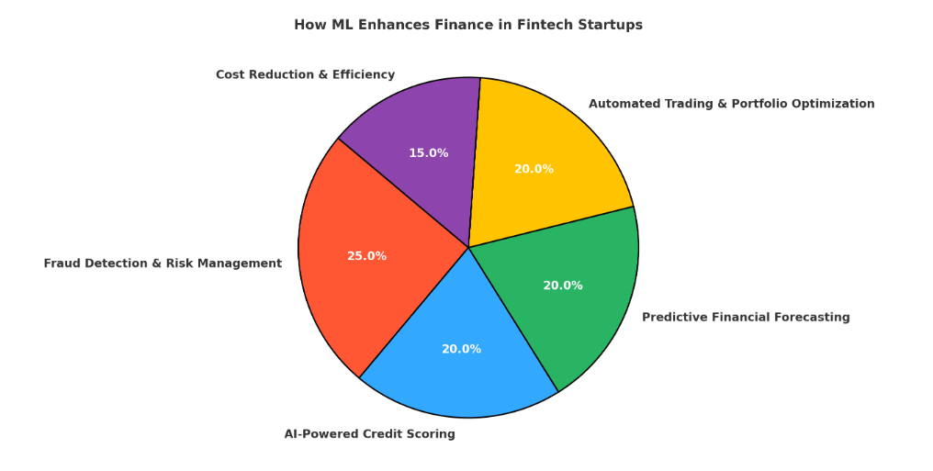**1. Finance: Strengthening Decision-Making and Risk Management**

**1.1 Fraud Detection and Risk Management**

In the fintech industry, cyber fraud remains one of the biggest threats. Traditional fraud detection methods struggle to keep up with the sheer volume of transactions, but ML-powered systems bring real-time fraud detection and risk management.

**How it works:**

* AI models continuously analyse transaction patterns to **detect anomalies**, such as unauthorized logins, fake identities, or unusual spending behaviour.
* ML-powered fraud detection systems **learn and evolve** to recognize new fraud techniques.

🔹 **Example:** PayPal uses advanced ML models to **detect fraudulent activities instantly**, preventing unauthorized transactions before they happen. This enhances security and reduces financial losses.

**1.2 AI-Powered Credit Scoring and Lending Decisions**

Traditional credit scoring models rely on past credit history, often excluding individuals with no credit background (e.g., young professionals, freelancers, small business owners). ML brings a more inclusive approach by analysing alternative financial data.

**How it works:**

* AI assesses a borrower’s spending patterns, bill payments, online transactions, and digital footprint to determine their creditworthiness.
* ML-powered lending models allow faster, more accurate loan approvals, reducing the risk of default.

🔹 **Example:** LendingKart, a fintech company offering loans to small businesses, uses ML-driven credit analysis to evaluate borrowers beyond traditional metrics, ensuring quicker approvals without requiring collateral.

**1.3 Predictive Financial Forecasting**

For fintech companies, accurate financial forecasting is essential for long-term growth, profitability, and investment planning. ML helps in predicting future revenues, cash flow trends, and investment risks by analysing vast amounts of data.

**How it works:**

* AI studies historical financial data, market conditions, and economic indicators to generate highly accurate financial forecasts.
* Predictive analytics helps reduce uncertainty and enables fintech firms to make data-driven strategic decisions.

🔹 **Example:** Hedge funds like Bridgewater Associates leverage ML-powered models to forecast market fluctuations, optimizing investment strategies and maximizing returns while minimizing risks.

**1.4 Automated Trading and Portfolio Optimization**

AI-driven algorithmic trading has revolutionized financial markets by removing human bias and improving trading efficiency.

**How it works:**

* ML algorithms analyse market trends, economic reports, and investor sentiment in real-time to identify profitable trades.
* Automated trading bots execute buy/sell decisions faster than human traders, ensuring better financial performance.

🔹 **Example:** Wealthfront, an investment platform, automates portfolio management using AI, adjusting investments based on risk tolerance, market trends, and user preferences.

**2. Operations: Increasing Efficiency in Financial Transactions**

A fintech startup’s success depends on smooth and secure financial operations. ML helps streamline critical processes, reducing errors and improving compliance.

**How it works:**

* AI automates Know Your Customer (KYC) and Anti-Money Laundering (AML) processes, ensuring regulatory compliance.
* ML-powered transaction monitoring flags suspicious activities before they escalate.

🔹 **Example:** **Digital banks like N26** use AI-powered identity verification to reduce onboarding time from days to minutes, improving customer experience while maintaining security.

**3. Marketing: AI-Driven Customer Acquisition in Fintech**

Fintech companies rely on ML to identify, attract, and retain the right customers while reducing marketing costs.

**How it works:**

* AI analyses customer behaviour, preferences, and financial habits to create hyper-personalized marketing campaigns.
* ML models determine which customers are most likely to convert, optimizing advertising budgets.

🔹 **Example:** **Insurtech firms** use ML to recommend insurance plans based on customer demographics, browsing behaviour, and financial history, increasing conversion rates.

**4. HR: Optimizing Workforce Productivity**

ML is transforming human resource management by streamlining hiring, training, and employee performance evaluation in fintech companies.

**How it works:**

* AI-powered recruitment tools analyse resume patterns, past performance, and skillsets to match the best candidates to job roles.
* ML models evaluate employee engagement and productivity, helping companies improve workplace efficiency.

🔹 **Example:** AI-driven recruitment platforms like HireVue use video interviews and predictive scoring to assess candidates, making the hiring process faster and more accurate for fintech firms.

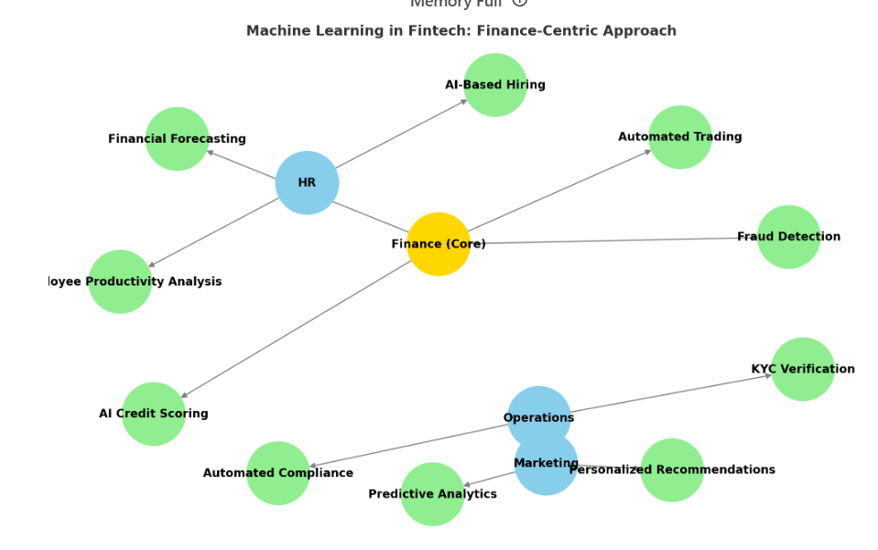

**How Machine Learning Helps Fintech Businesses**

**PayPal: Stopping Fraud and Making Payments Safer**

PayPal is one of the biggest online payment companies. Millions of people send and receive money through PayPal every day. But with so many transactions happening, it is difficult to catch fraud manually. This is where machine learning helps.

Machine learning studies how users normally make payments. It looks at their past transactions, the device they use, and their regular behaviour. If something looks unusual, the system quickly flags it as suspicious.

For example, if a person who usually sends small amounts suddenly tries to send a very large amount to another country, machine learning will mark it as a possible fraud. PayPal will then check the transaction before approving or blocking it.

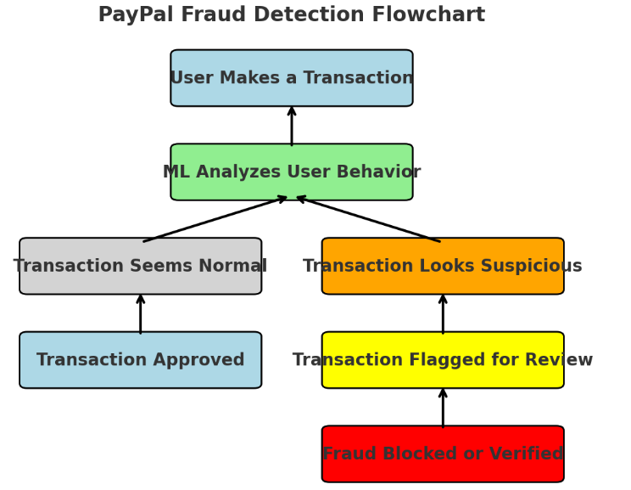

**How Machine Learning Makes PayPal Better**

It detects fraud much faster. Earlier, it took a long time to catch fraud because people had to check transactions manually. Now, machine learning can do it instantly.

It reduces wrong transaction blocks. Sometimes, a real transaction gets stopped by mistake. Machine learning helps approve genuine payments more accurately, so customers do not face problems.

It saves a lot of money. By stopping fraud in time, PayPal avoids losing millions of dollars. Customers also feel safer using the platform.

**How ML Improves Efficiency:**

**90% faster fraud detection** – Before ML, fraud detection took much longer because it relied on manual reviews. Now, ML instantly flags risky transactions.  
 **Reduces false declines by 50%** – Sometimes, real transactions get wrongly blocked due to security checks. ML helps approve genuine payments faster, improving customer satisfaction.  
 **Saves millions of dollars** – With better fraud prevention, PayPal avoids huge financial losses while keeping customer trust strong.

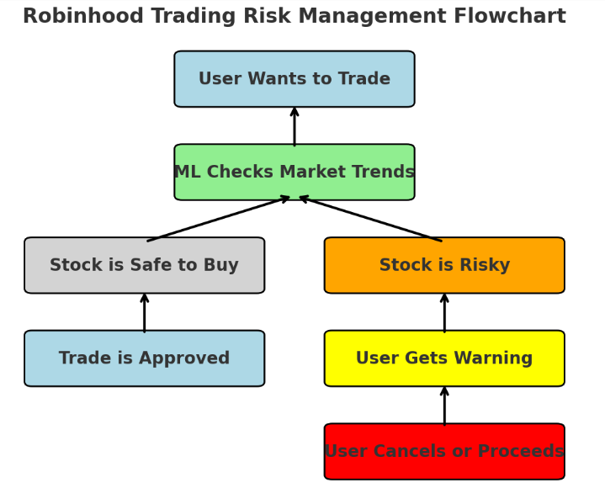

**Robinhood: Making Trading Easier and Safer**

Robinhood is an app that helps people buy and sell stocks. It uses machine learning to give better investment suggestions and warn users about risky trades.

Machine learning looks at how a user invests, checks market trends, and studies financial news. Based on this, it suggests stocks and other assets that match the user’s interest and risk level.

It also helps in risk management. When a person wants to buy a stock, the system quickly checks past market data and current conditions. If the trade seems too risky, the app warns the user before they invest.

For example, if a stock is highly unpredictable and can cause big losses, machine learning will alert the user. This helps people make smarter investment decisions.

**How Machine Learning Makes Robinhood Better**

It helps predict risks more accurately. The system warns users about risky trades much better than before, reducing losses.

It answers user questions much faster. Instead of waiting for a human to reply, a chatbot powered by machine learning gives instant and helpful answers.

It gives better investment suggestions. Machine learning studies a user’s choices and market trends to recommend stocks that suit their needs. This makes trading easier, especially for beginners.

**How ML Improves Efficiency:**

**50% better risk predictions** – ML helps Robinhood identify risky trades more accurately, reducing potential losses for users.  
 **80% faster customer support** – Instead of waiting for human agents, users get instant answers from an ML-powered chatbot.  
 **Personalized trading recommendations** – ML analyses data in real time to suggest the best investment options, making trading easier for beginners.

**Conclusion**

Machine learning is changing the way fintech businesses operate. It helps companies like PayPal and Robinhood work faster, smarter, and more securely.

For PayPal, machine learning has made fraud detection almost instant. It spots suspicious transactions before they happen, saving the company millions of dollars and keeping customers' money safe. It also makes sure that real transactions are not wrongly blocked, making payments smooth and hassle-free.

For Robinhood, machine learning acts like a smart assistant for investors. It suggests the best stocks based on market trends and personal preferences. It also warns users about risky trades, helping them make better investment decisions. Plus, Robinhood's chatbot, powered by machine learning, answers questions quickly, making customer support much more efficient.

Overall, machine learning is making fintech businesses more reliable, user-friendly, and profitable. It saves time, reduces errors, and improves customer satisfaction. As technology keeps evolving, fintech companies that use machine learning will continue to grow and provide better services to their users.

**REFRENCES**

Brown, Richard. 2022. *Machine Learning in Fintech: How AI is Changing the Financial Industry*. Harvard Business Review. Retrieved March 23, 2025 (<https://www.hbr.org>).

PayPal. 2023. *How PayPal Uses Machine Learning for Fraud Detection*. PayPal Official Blog. Retrieved March 23, 2025 (<https://www.paypal.com>).

McKinsey & Company. 2023. *The Role of AI in Financial Services: Enhancing Security and Efficiency*. Retrieved March 23, 2025 (<https://www.mckinsey.com>).

Deloitte. 2023. *The Future of Fintech: How Machine Learning is Reshaping Financial Services*. Retrieved March 23, 2025 (<https://www.deloitte.com>).